Singapore company name: STR Technologies
Domain: STRSG.com
It serves as the international hub for API and adjuvant products from BDyn Bio (China)
Website/shop target audience: biotech research community
A reference site: https://www.invivogen.com/vaccine-adjuvants

Introduction to Synthetic Adjuvants from BDSyn Bio

QS-21-Api

QS-21 is a potent vaccine adjuvant and critical to the success of several important vaccines, including Mosquirix®, Shingrix® and Covovax®. Traditionally derived from native Chilean Quillaja saponaria tree bark, QS-21 is a mixture of primarily QS-21-Api and QS-21-Xyl (65:35 ratio), plus other similar saponins.
BDSyn Bio has pioneered a proprietary chemical-synthetic process for QS-21-Api that is highly efficient and scalable, delivering accessiblity and security of supply. Synthetic QS-21-Api demonstrates equivalent immunogenicity and reactogenicity profiles to naturally sourced QS-21 in animal models. GMP-grade synthetic QS-21-Api is also now available for order.

We also offer synthetic QS-21-Xyl and other QS-21-like saponins.

- High Purity
- GMP Grade
- Sustainable
- Accessible
- Security of Supply
- Freedom to operate
- A wide range of synthetic saponins is available

HMLA
The synergistic effect of a TLR4 agonist, 3-O-desacyl-4'-monophosphoryl lipid A (MPLA) and QS-21 in a liposomal formulation, such as the AS01 adjuvant, induces potent humoral and Th1-type cellular immune responses, which is key to the superior efficacy of vaccines like Shingrix®.
MPLA, derived from Salmonella LPS through acid hydrolysis, is heterogeneous with HMLA (Hexa-acyl Monophosphoryl Lipid A) as the dominant and active constituent. BDSyn Bio’s synthetic HMLA has the advantages of defined chemical structure, much improved batch-to-batch consistency and process economics. It has been utilised in vaccine development for diseases such as herpes zoster, malaria and tuberculosis.

- High Purity
- GMP Grade
- Sustainable
- Accessible
- Security of Supply
- Freedom to operate
- A wide range of synthetic MPLA is available

TDB
D-(+)-Trehalose 6,6'-dibehenate (TDB) is a synthetic lipid that has been shown to enhance vaccine immunogenicity when incorporated into cationic liposomes composed of DDA, forming systems like DDA/TDB and CAF01. It promotes robust cell-mediated (Th1/Th17) and antibody responses by stabilising the liposomal structure, improving antigen delivery, and acting as an immunomodulator. Additionally, TDB serves as a cryoprotectant during lyophilisation, ensuring long-term stability and efficacy of the vaccine formulation.

- High Purity
- GMP Grade
- FDADMF 040613
- NMPA F20230000625

Company Introduction
BDSyn Bio specialises in the development and manufacture of advanced vaccine adjuvants. Leveraging proprietary technologies and in-depth expertise, the company offers a diverse range of synthetic, clinically important adjuvants, benefiting from much improved accessibility and security of supply. GMP-grade adjuvants are also now available for vaccine developers.
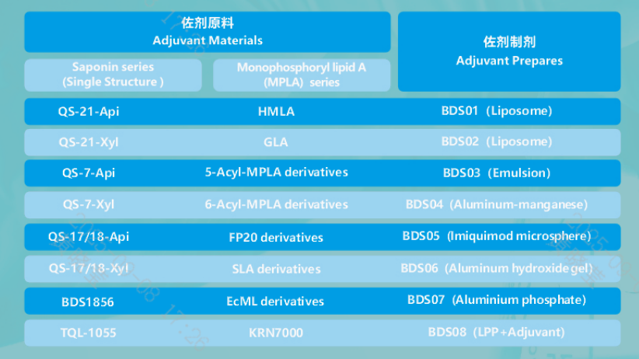

Chongqing BDSyn Biotechnology Co., Ltd.
Address: D2-10, International Student Entrepreneurship Park, No.77 Kecheng Road, Jiulongpo District, Chongqing, China
Contact: Ms. Huang, +8613350310947
Email: huangxiaoying@bdsynbiotech.com

Slogan?
Synthetic Saponins For More Accessible Vaccines

